UNIT - III
Class Diagrams & Object Diagrams
Class Diagrams:
- You use class diagrams to model the static design view of a system.
- For the most part, this involves modeling the vocabulary of the system, modeling collaborations, or modeling schemas.
- Class diagrams are important not only for visualizing, specifying, and documenting structural models, but also for constructing executable systems through forward and reverse engineering.
- You use class diagrams to visualize the static aspects of these building blocks and their relationships and to specify their details for construction, as you can see in Figure.
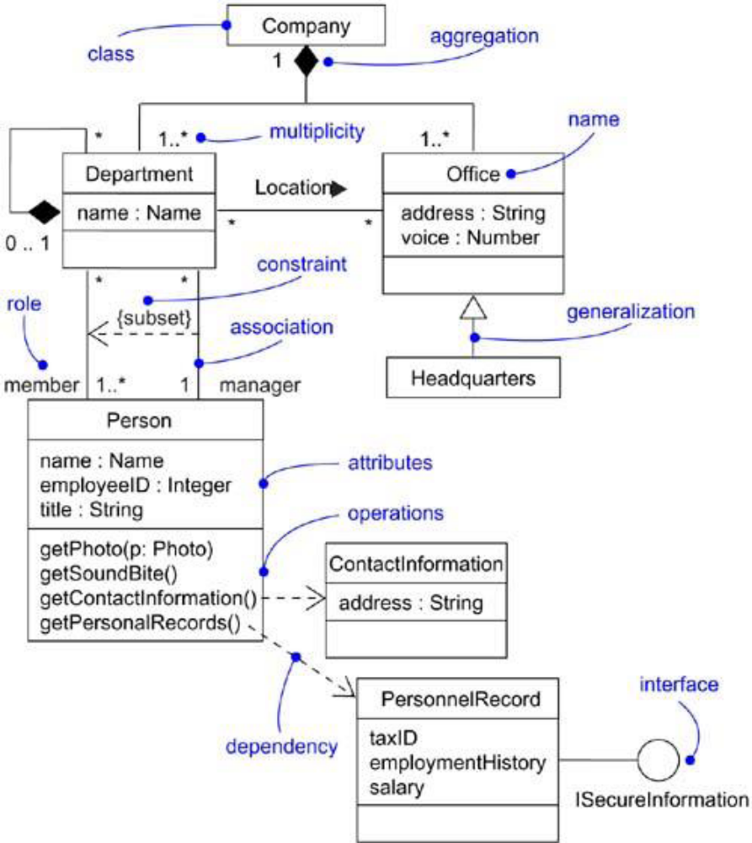

Figure. A Class Diagram

Terms and Concepts:
- A class diagram is a diagram that shows a set of classes, interfaces, and collaborations and their relationships.
- Graphically, a class diagram is a collection of vertices and arcs.
Common Properties:
- A class diagram is just a special kind of diagram and shares the same common properties as do all other diagrams - a name and graphical content that are a projection into a model.
- What distinguishes a class diagram from all other kinds of diagrams is its particular content.
Contents:
  - Class diagrams commonly contain the following things:
- Classes
- Interfaces
- Collaborations
- Dependency, generalization, and association relationships
- Like all other diagrams, class diagrams may contain notes and constraints.
- Class diagrams may also contain packages or subsystems, both of which are used to group elements of your model into larger chunks.
- When you want to visualize the type of an instance you want to place instance in diagram.
Common uses:
- Class diagrams are used to model the static design view of a system.
- This view primarily supports the functional requirements of a system, the services the system should provide to its end users.
- When you model the static design view of a system, you'll typically use class diagrams in one of three ways.
1. To model the vocabulary of a system
- It involves making a decision about which abstractions are a part of the system under consideration and which fall outside its boundaries.
- You use class diagrams to specify these abstractions and their responsibilities.
2. To model simple collaborations
- Collaboration is a society of classes, interfaces, and other elements that work together to provide some cooperative behavior that's bigger than the sum of all the elements.
- For example, when you need to model the semantics of a transaction in a distributed system, you can't depend on a single class to understand what's going on.
- You need to consider set of classes that work together.
- So, you use class diagrams to visualize and specify this set of classes and their relationships.
3. To model a logical database schema
- Schema is a blueprint for the conceptual design of a database.
- In many domains, you want to store persistent information in a relational database or in an object-oriented database.
- You can model schemas for these databases using class diagrams.
Common Modeling Techniques:
Modeling Simple Collaborations
- No class stands alone.
- Each works in collaboration with others to carry out some work greater than each individual.
- You need to pay your attention for visualizing, specifying, constructing, and documenting the various ways these things in your vocabulary work together.
- You use class diagrams to represent such collaborations.
- When you create a class diagram, you just model a part of the things and relationships that make up your system's design view.
- Each class diagram should focus on one collaboration at a time.
To model a collaboration,
- Identify the mechanism you'd like to model. A mechanism represents some function or behavior of the part of the system you are modeling.
- For each mechanism, identify the classes, interfaces, and other collaborations that participate in this collaboration. Identify the relationships among these things, as well.
- Use scenarios to walk through these things. To discover parts of your model that were missing and parts that were semantically wrong.
- Populate these elements with their contents. For classes, start with getting a good balance of responsibilities, attributes and operations.
- For example, fig. shows a set of classes drawn from the implementation of an autonomous robot.
- Mechanism, moving the robot along a path.
- You'll find one abstract class (Motor) with two concrete children, SteeringMotor and MainMotor.
- Both of these classes inherit the five operations of their parent, Motor.
- Two classes are, in turn, shown as parts of another class, Driver.
- The class PathAgent has a one-to-one association to Driver and a one-to-many association to CollisionSensor.
- No attributes or operations are shown for PathAgent, although its responsibilities are given.
- There are many more classes involved in this system, but this diagram focuses only on those abstractions that are directly involved in moving the robot.
- You'll see some of these same classes in other diagrams.
- For example, although not shown here, the class PathAgent collaborates with Environment and GoalAgent. Similarly, also not shown here, the classes CollisionSensor and Driver (and its parts) collaborate with another class (FaultAgent) in a mechanism responsible for continuously checking the robot's hardware for errors.
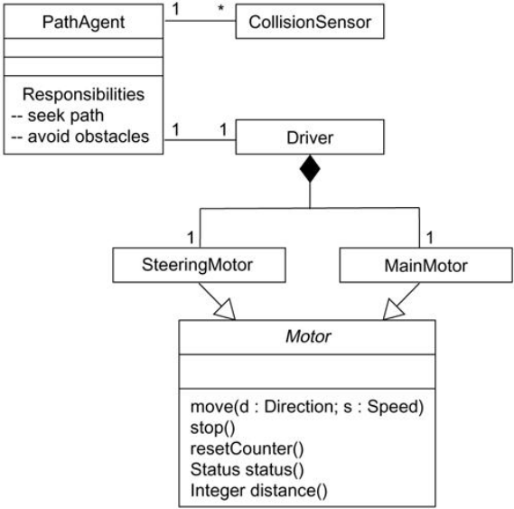
Figure. Modeling Simple Collaborations
Modeling a Logical Database Schema
- Many of the systems will have persistent objects, which means that they can be stored in a database for later retrieval.
- You use a relational database, an object oriented database, or a hybrid object/relational database for persistent storage.
- The UML is well suited to modeling logical database schemas, as well as physical databases schemas.
- The UML's class diagrams are a superset of entity-relationship (E-R) diagrams.
- E-R diagrams focus only on data, class diagrams go a step further by permitting the modeling of behavior.
- In the physical database, these logical operations are generally turned into triggers or stored procedures.
To model a schema,
- Identify those classes in your model whose state must transcend the lifetime of their applications.
- Create a class diagram that contains these classes and mark them as persistent (a standard tagged value). You can define your own set of tagged values to address database-specific details.
- Expand the structural details of these classes.
- Watch for common patterns that complicate physical database design, such as cyclic associations, one-to-one associations, and n-ary associations. Where necessary, create intermediate abstractions to simplify your logical structure.
- Consider also the behavior of these classes by expanding operations that are important for data access and data integrity.
- Where possible, use tools to help you transform your logical design into a physical design.
- Figure. shows a set of classes drawn from an information system for a school.
- This figure expands upon an earlier class diagram, and you'll see the details of these classes revealed to a level sufficient to construct a physical database.
- There's an association between Student and Course, specifying that students attend courses.
- Furthermore, every student may attend any number of courses and every course may have any number of students.
- All five of these classes are marked as persistent, indicating that their instances are intended to live in a database or some other form of persistent store.
- This diagram also exposes the attributes of all five of these classes.
- All the attributes are primitive types.
- When you model a schema, you generally want to model the relationship to any nonprimitive types using an explicit aggregation rather than an attribute.
- Two of these classes (School and Department) expose several operations for manipulating their parts.
- These operations are included because they are important to maintain data integrity
(adding or removing a Department, for example, will have some rippling effects).
- There are many other operations that you might consider for these and the other classes.
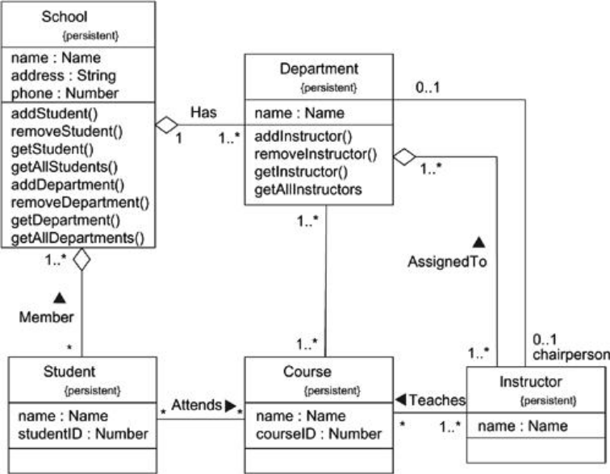
Fig. Modeling a Schema
Forward and Reverse Engineering
- Modeling is important, but you have to remember that the primary product of a development team is software, not diagrams.
- So, models you create and the implementations need to be correctly mapped to another
- The UML will not map to any specific object - oriented programming language.
- The class diagrams, contents have a clear mapping to all object-oriented languages, such as Java, C++, Smalltalk, Ada, etc.,
- Forward engineering is the process of transforming a model into code through a mapping to an implementation language.
- Forward engineering results in a loss of information, because models written in the UML are semantically richer than any current object-oriented programming language.
- Structural features, such as collaborations, and behavioral features, such as interactions, can be visualized clearly in the UML, but not so clearly from raw code.
To forward engineer a class diagram,
- Identify the rules for mapping to your implementation language or languages of choice.
- Depending on the semantics of the languages you choose, you may want to constrain your use of certain UML features. For example, the UML permits you to model multiple inheritance, but Smalltalk permits only single inheritance. You can either choose to prohibit developers from modeling with multiple inheritance (which makes your models language-dependent) or develop idioms that transform these richer features into the implementation language (which makes the mapping more complex).
- Use tagged values to specify your target language. You can do this at the level of individual classes if you need precise control. You can also do so at a higher level, such as with collaborations or packages.
- Use tools to forward engineer your models.
- Figure. Shows Forward Engineering
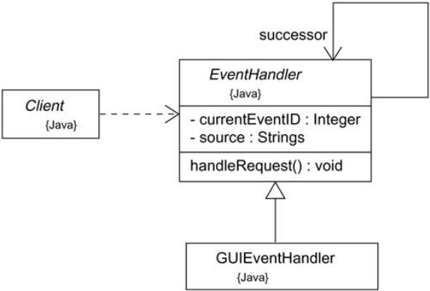
Figure. Forward Engineering
- All of these classes specify a mapping to Java, as noted in their tagged value.
- Forward engineering the classes in this diagram to Java is straightforward, using a tool. Forward engineering the class EventHandler yields the following code.

public abstract class EventHandler {
EventHandler successor;
private Integer currentEventID;
private String source;
EventHandler() {}
public void handleRequest() {}
}

- Reverse engineering is the process of transforming code into a model through a mapping from a specific implementation language.
- It results in a flood of information, some of which is at a lower level of detail than you'll need to build useful models.
- So, reverse engineering is incomplete.
- There is a loss of information when forward engineering models into code, and so you can't completely recreate a model from code unless your tools encode information in the source comments that goes beyond the semantics of the implementation language.
To reverse engineer a class diagram,
- Identify the rules for mapping from your implementation language or languages of choice.
- Using a tool, point to the code you'd like to reverse engineer or to generate a new model or modify an existing that was previously forward engineered.
- Using your tool, create a class diagram by querying the model. For example, you might start with one or more classes, and then expand the diagram by following specific relationships or other neighboring classes.
- Expose or hide details of the contents of this class diagram as necessary to communicate your intent.
- Manually add design information to the model to express the intent of the design that is missing or hidden in the code.

Object Diagram:
- You need to study snapshot of the objects, its neighbors, and its relationships to these neighbors could be done by using object diagram.
- Object diagrams model the instances of things contained in class diagrams.
- An object diagram shows a set of objects and their relationships at a point in time.
- You use object diagrams to model the static design view or static process view of a system.
- It involves modeling a snapshot of the system at a moment in time and rendering a set of objects, their state, and their relationships.
- It is used for constructing the static aspects of systems through forward and reverse engineering.
- If you are not used to the game, soccer looks like a terribly simple sport, people madly running about a field chasing a white ball.
- You could see blurred image of bodies in motion.
- Freeze the motion for a moment, then classify the individual players, and a very different picture of the game emerges.
- Dig a bit deeper and you'll understand how these players collaborate, for goal-tending, moving the ball, stealing the ball, and attacking.
- Every moment of the game, you'll find their placement on the field and their relationship to other players well calculated.
- An object diagram covers a set of instances of the things found in a class diagram. An object diagram.
- Therefore, expresses the static part of an interaction, consisting of the objects that collaborate, but without any of the messages passed among them.
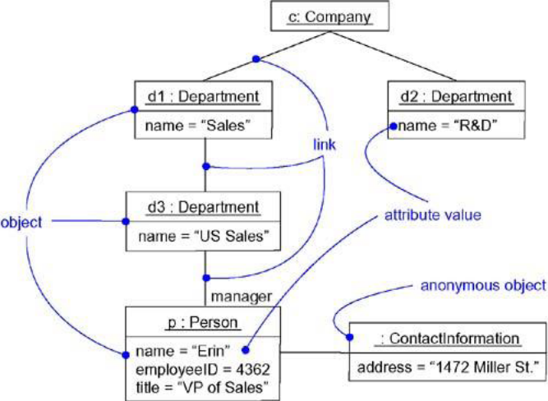
Figure. An Object Diagram
Terms and Concepts:
- An object diagram is a diagram that shows a set of objects and their relationships at a point in time.
- Graphically, an object diagram is a collection of vertices and arcs
Common Properties:
- An object diagram is a special kind of diagram and shares the same common properties as all other diagrams - that is, a name and graphical contents that are a projection into a model.
- What distinguishes an object diagram from all other kinds of diagrams is its particular content.
Contents:
- Object diagrams commonly contain
- Objects
- Links
- Like all other diagrams, object diagrams may contain notes and constraints.
- Object diagrams may also contain packages or subsystems, both of which are used to group elements of your model into larger chunks.
- When you want to visualize the classes behind each instance then you could place classes in object diagram.
Common Uses:
- You use object diagrams to model the static design view or static process view of a system
- Class diagram supports the functional requirements of a system - that is, the services the system should provide to its end users.
- Object diagrams let you model static data structures.
To model object structures
- Modeling object structures involves taking a snapshot of the objects in a system at a given moment in time.
- An object diagram represents one static frame in the dynamic storyboard represented by an interaction diagram.
- You use object diagrams to show the existence of certain instances in your system, together with their relationships to one another.
Common Modeling Techniques
Modeling Object Structures
- When you construct a class diagram, a component diagram, or a deployment diagram, what you are really doing is capturing a set of abstractions that are interesting to you as a group and relationship to other group.
- If class A has a one-to-many association to class B, then for one instance of A there might be five instances of B; for another instance of A there might be only one instance of B.
- At a given moment in time, that instance of A, along with the related instances of B, will each have certain values for their attributes and state machines.
- If you freeze a running system or just imagine a moment of time, you'll find a set of objects, each in a specific state, and each in a particular relationship to other objects.
- Object diagrams are especially useful for modeling complex data structures.
- When you model your system's design view, a set of class diagrams can be used to completely specify the semantics of your abstractions and their relationships.
- With object diagrams, you cannot completely specify the object structure of your system.
- For an individual class, there may be a many of possible instances.
- Therefore, when you use object diagrams, you can only meaningfully expose interesting sets of concrete or prototypical objects.
- This is what it means to model an object structure - an object diagram shows one set of objects in relation to one another at one moment in time.
To model an object structure,
- Identify the mechanism you'd like to model. A mechanism represents some function or behavior of the part of the system.
- For each mechanism, identify the classes, interfaces, and other elements that participate in this collaboration; identify the relationships among these things, as well.
- Consider one scenario that walks through this mechanism. Freeze that scenario at a moment in time, and render each object that participates in the mechanism.
- Expose the state and attribute values of each such object, as necessary, to understand the scenario.
- Similarly, expose the links among these objects, representing instances of associations among them.
- For example, shows a set of objects drawn from the implementation of an autonomous robot.
- This figure focuses on some of the objects involved in the mechanism used by the robot to calculate a model of the world in which it moves.
- There are many more objects involved in a running system, but this diagram focuses on only those abstractions that are directly involved in creating this world view.
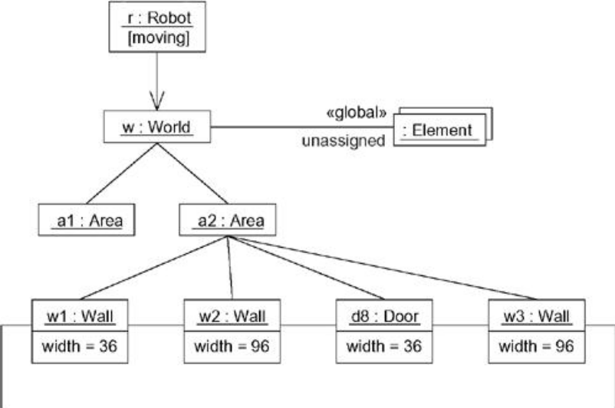
Figure. Modeling Object Structures
- As this figure indicates, one object represents the robot itself (r, an instance of Robot), and r is currently in the state marked moving.
- This object has a link to w, an instance of World, which represents an abstraction of the robot's world model.
- This object has a link to a multiobject that consists of instances of Element, which represent entities that the robot has identified but not yet assigned in its world view.
- These elements are marked as part of the robot's global state.
- At this moment in time, w is linked to two instances of Area.
- One of them (a2) is shown with its own links to three Wall and one Door object.
- Each of these walls is marked with its current width, and each is shown linked to its neighboring walls.
- As this object diagram suggests, the robot has recognized this enclosed area, which has walls on three sides and a door on the fourth.
Forward and Reverse Engineering
- Forward engineering (the creation of code from a model) an object diagram is theoretically possible but practically of limited value.
- In an object-oriented system, instances are things that are created and destroyed by the application during run time. Therefore, you can't exactly instantiate these objects from the outside.
- Reverse engineering (the creation of a model from code) an object diagram is a very different thing.
To reverse engineer an object diagram,
- Chose the target you want to reverse engineer. Typically, you'll set your context inside an operation or relative to an instance of one particular class.
- Using a tool or simply walking through a scenario, stop execution at a certain moment in time.
- Identify the set of interesting objects that collaborate in that context and render them in an object diagram.
- As necessary to understand their semantics, expose these object's states.
- As necessary to understand their semantics, identify the links that exist among these objects.
- If your diagram ends up overly complicated, remove it by eliminating objects that are not relevant to the questions about the scenario you need answered. If your diagram is too simplistic, expand the neighbors of certain interesting objects and expose each object's state more deeply.

Basic Behavioral Modeling - I
Interactions:
- In every interesting system, objects don't just sit idle; they interact with one another by passing messages.
- An interaction is a behavior that comprises a set of messages exchanged among a set of objects within a context to accomplish a purpose.
- You use interactions to model the dynamic aspect of collaborations.
- The dynamic aspects are visualized, specified, constructed, and documented as flows of control that may encompass simple, sequential threads through a system, as well as more-complex flows that involve branching, looping, recursion, and concurrency.
- You can model each interaction in two ways:
a) by emphasizing its time ordering of messages, or
b) by emphasizing its sequencing of messages in the context of some structural organization of objects.
- Well-structured interactions are like well-structured algorithms• efficient, simple, adaptable, and understandable.
- In the UML, you model the static aspects of a system by using such elements as class diagrams and object diagrams. These diagrams let you visualize, specify, construct, and document the things that live in your system, including classes, interfaces, components, nodes, and use cases and their instances, together with the way those things sit in relationship to one another.
- In the UML, you model the dynamic aspects of a system by using interactions by introducing messages that are dispatched from object to object. messages involve the invocation of an operation or the sending of a signal; messages may also encompass the creation and destruction of other objects.
- You use interactions to model the flow of control within an operation, a class, a component, a use case, or the system as a whole. Using interaction diagrams, you can reason about these flows in two ways. First, you can focus on how messages are dispatched across time. Second, you can focus on the structural relationships among the objects in an interaction and then consider how messages are passed within the context of that structure.
- The UML provides a graphical representation of messages, as Figure. shows.
- This notation permits you to visualize a message in a way that lets you emphasize its most important parts: its name, parameters (if any), and sequence. Graphically, a message is rendered as a directed line and almost always includes the name of its operation.
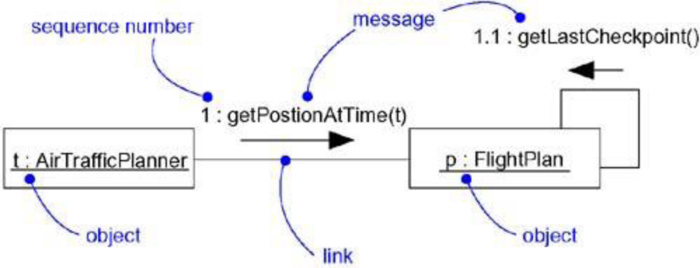

Figure. Messages, Links, and Sequencing

Terms and Concepts
An interaction is a behavior that comprises a set of messages exchanged among a set of objects within a context to accomplish a purpose. A message is a specification of a communication between objects that conveys information with the expectation that activity will ensue.
Context
- You may find an interaction wherever objects are linked to one another.
- You'll find interactions
- in the collaboration of objects that exist in the context of your system or subsystem.
- the context of an operation.
- the context of a class.
Objects and Roles
- The objects that participate in an interaction are either concrete things or prototypical things.
- As a concrete thing, an object represents something in the real world.
- For example, p, an instance of the class Person, might denote a particular human. Alternately, as a prototypical thing, p might represent any instance of Person.
- In the context of an interaction, you may find instances of classes, components, nodes, and usecases.
- Abstract classes and interfaces, by definition, may not have any direct instances, you may find instances of these things in an interaction.
- Such instances do not represent direct instances of the abstract class or of the interface, but may represent, respectively, indirect (or prototypical) instances of any concrete children of the abstract class of some concrete class that realizes that interface.
- An interaction goes further by introducing a dynamic sequence of messages that may pass along the links that connect these objects.
Links
- A Link is a semantic connection among objects.
- A link is an instance of an association.
- Wherever a class has an association to another class, there may be a link between the instances of the two classes; wherever there is a link between two objects, one object can send a message to the other object.
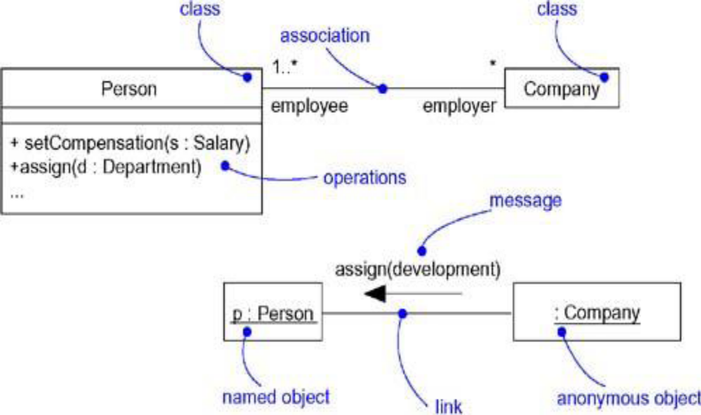

Figure. Links and Associations
- A link specifies a path along which one object can dispatch a message to another (or the same) object. Most of the time, it is sufficient to specify that such a path exists. If you need to be more precise about how that path exists, you can adorn the appropriate end of the link with any of the following standard stereotypes.
- association: Specifies that the corresponding object is visible by association
- self: Specifies that the corresponding object is visible because it is the dispatcher of the operation
- global Specifies that the corresponding object is visible because it is in an enclosing scope
- local Specifies that the corresponding object is visible because it is in a local scope
- parameter Specifies that the corresponding object is visible because it is a parameter
Messages:
- Object diagrams model the state of a society of objects at a given moment in time and are useful when you want to visualize, specify, construct, or document a static object structure.
- If you want to model the changing state of a society of objects over a period of time.
- If the objects are not totally idle, you'll see objects passing messages to other objects, sending events, and invoking operations.
- In addition, at each frame, you can explicitly visualize the current state and role of individual instances.
- A message is the specification of a communication among objects that conveys information with the expectation that activity will ensue.
- The receipt of a message instance may be considered an instance of an event.
- When you pass a message, the action that results is an executable statement that forms an abstraction of a computational procedure.
- An action may result in a change in state.
- In the UML, you can model several kinds of actions.
- Call: Invokes an operation on an object; an object may send a message to itself, resulting in the local invocation of an operation
- Return: Returns a value to the caller
- Send: Sends a signal to an object
- Create: Creates an object Destroy
- Destroys an object; an object may commit suicide by destroying itself
- The UML provides a visual distinction among these kinds of messages, as Figure shows.
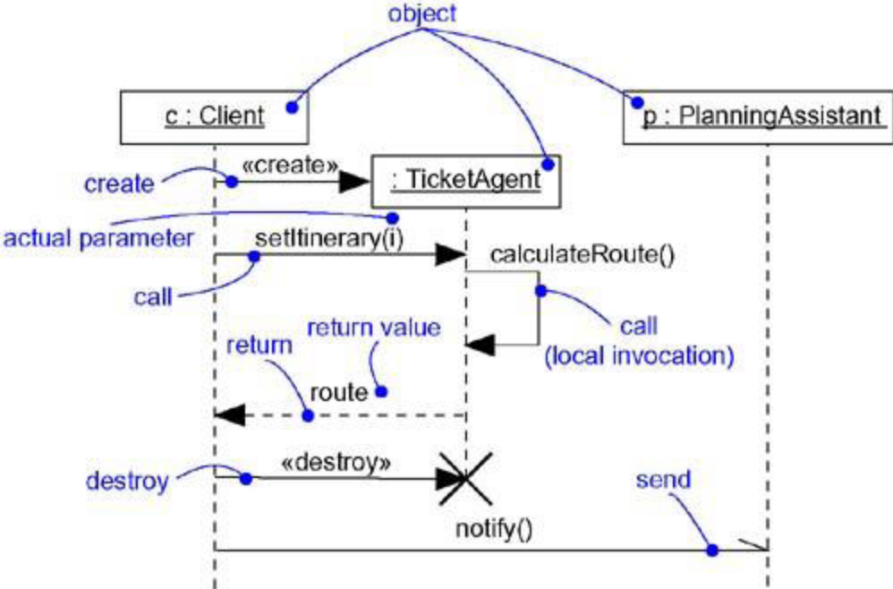
- The most common kind of message you'll model is the call, in which one object invokes an operation of another (or the same) object.
- An object can't just call any random operation.
- If an object, such as c in the example above, calls the operation setItinerary on an instance of the class TicketAgent, the operation setItinerary must not only be defined for the class TicketAgent (that is, it must be declared in the class TicketAgent or one of its parents), it must also be visible to the caller c.
- When an object calls an operation or sends a signal to another object, you can provide actual parameters to the message. Similarly, when an object returns control to another object, you can model the return value, as well.

Sequencing
- When an object passes a message to another object (in effect, delegating some action to the receiver), the receiving object might in turn send a message to another object, which might send a message to yet a different object, and so on. This stream of messages forms a sequence.
- Any sequence must have a beginning; the start of every sequence is rooted in some process or thread.
- Each process and thread within a system defines a distinct flow of control, and within each flow, messages are ordered in sequence by time.
- To better visualize the sequence of a message, you can explicitly model the order of the message relative to the start of the sequence by prefixing the message with a sequence number set apart by a colon separator.
- You can specify a procedural or nested flow of control, rendered using a filled solid arrowhead, as Figure shows.
- In this case, the message findAt is specified as the first message nested in the second message of the sequence (2.1).
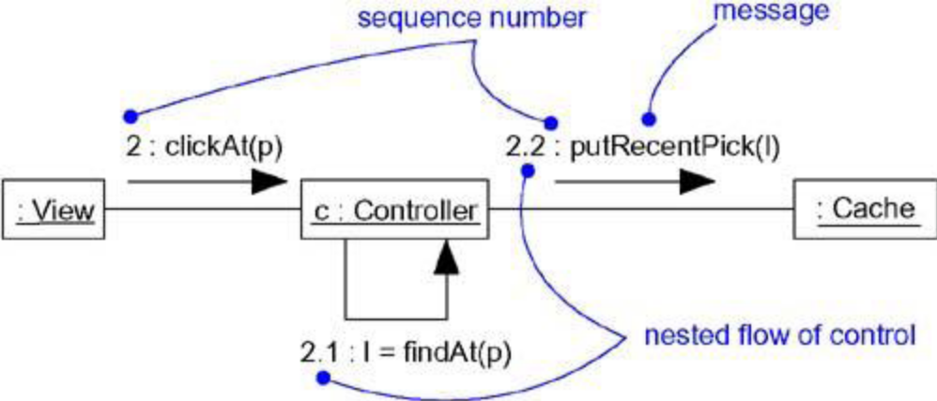
Figure. Procedural Sequence

- Less common but also possible, as Figure. shows, you can specify a flat flow of control, rendered using a stick arrowhead, to model the nonprocedural progression of control from step to step.
- In this case, the message assertCall is specified as the second message in the sequence.

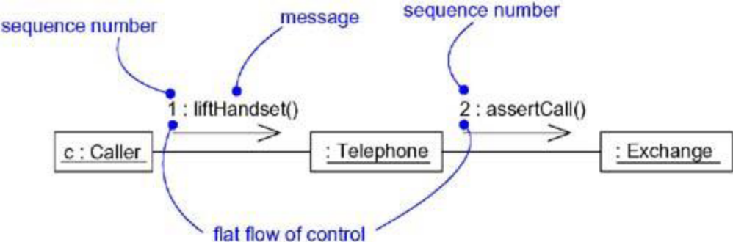

Figure. Flat Sequence

- When you are modeling interactions that involve multiple flows of control, it's especially important to identify the process or thread that sent a particular message.
- In the UML, you can distinguish one flow of control from another by prefixing a message's sequence number with the name of the process or thread that sits at the root of the sequence.
- For example, the expression
D5 : ejectHatch(3)
specifies that the operation ejectHatch is dispatched (with the actual argument 3) as the fifth message in the sequence rooted by the process or thread named D.
- Even you can show the return values of a function as well.
1.3.2 : p := find("Rachelle")

Creation, Modification, and Destruction
- The objects you show participating in an interaction exist for the entire duration of the interaction.
- In some interactions, objects may be created and destroyed.
- The same is true of links: the relationships among objects may come and go.
- To specify if an object or link enters and/or leaves during an interaction, you can attach one of the following constraints to the element:
- new: Specifies that the instance or link is created during execution of the enclosing interaction
- destroyed: Specifies that the instance or link is destroyed prior to completion of execution of the enclosing interaction
- transient: Specifies that the instance or link is created during execution of the enclosing
- interaction but is destroyed before completion of execution
- During an interaction, an object typically changes the values of its attributes, its state, or its roles.
- You can represent the modification of an object by replicating the object in the interaction.
- On a sequence diagram, you'd place each variant of the object on the same lifeline.
- In an interaction diagram, you'd connect each variant with a become message.
Representation
- When you model an interaction, you typically include both objects or roles and messages.
- You can visualize those objects and messages involved in an interaction in two ways:
- by emphasizing the time ordering of its messages, and
- by emphasizing the structural organization of the objects that send and receive messages.
- In the UML, the first kind of representation is called a sequence diagram;
- the second kind of representation is called a collaboration diagram.
- Both sequence diagrams and collaboration diagrams are kinds of interaction diagrams.
- Sequence diagrams and collaboration diagrams are largely isomorphic, meaning that you can take one and transform it into the other without loss of information.
- There are some visual differences
- First, sequence diagrams permit you to model the lifeline of an object.
- An object's lifeline represents the existence of the object at a particular time, possibly covering the object's creation and destruction.
- Second, collaboration diagrams permit you to model the structural links that may exist among the objects in an interaction.
Common Modeling Techniques
Modeling a Flow of Control
- The most common purpose for which you'll use interactions is to model the flow of control that characterizes the behavior of a system as a whole, including use cases, patterns, mechanisms, and frameworks, or the behavior of a class or an individual operation.
- Whereas classes, interfaces, components, nodes, and their relationships model the static aspects of your system, interactions model its dynamic aspects.
- When we model an interaction, you essentially build a storyboard of the actions that take place among a set of objects.
To model a flow of control,
- Set the context for the interaction, whether it is the system as a whole, a class, or an individual operation.
- Set the stage for the interaction by identifying which objects play a role; set their initial properties, including their attribute values, state, and role.
- If your model emphasizes the structural organization of these objects, identify the links that connect them, relevant to the paths of communication that take place in this interaction.
- In time order, specify the messages that pass from object to object.
- As necessary, distinguish the different kinds of messages; include parameters and return values to convey the necessary detail of this interaction.
- Also to convey the necessary detail of this interaction, adorn each object at every moment in time with its state and role.
- For example, shows a set of objects that interact in the context of a publish and subscribe mechanism (an instance of the observer design pattern).
- This figure includes three objects: p (a StockQuotePublisher), s1, and s2 (both instances of StockQuoteSubscriber).
- This figure is an example of a sequence diagram, which emphasizes the time order of messages.
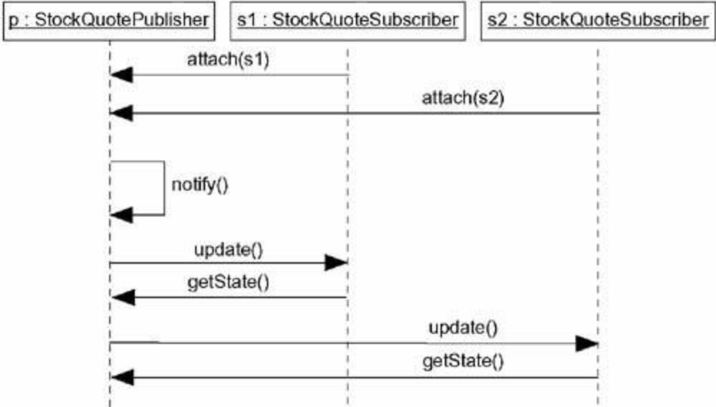

Figure. Flow of Control by Time
- Figure below is semantically equivalent to the previous one, but it is drawn as a collaboration diagram, which emphasizes the structural organization of the objects.
- This figure shows the same flow of control, but it also provides a visualization of the links among these objects.
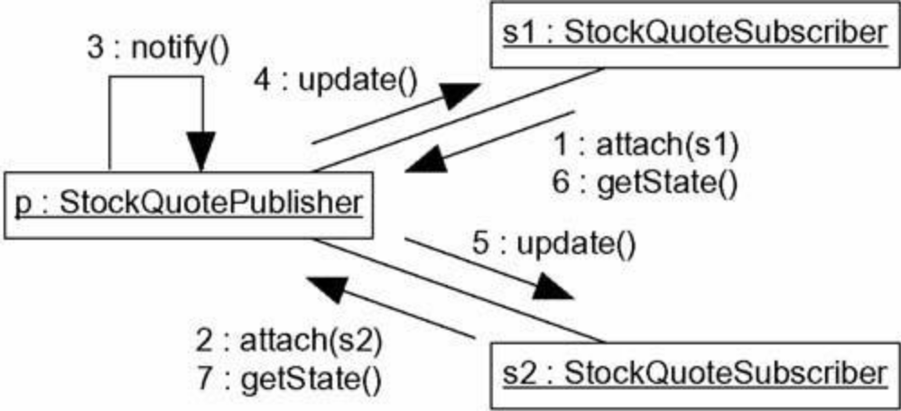

Figure. Flow of Control by Organization

Interaction Diagrams:
- Sequence diagrams and collaboration diagrams are collectively called interaction diagrams
- These diagrams in UML are used to model the dynamic aspects of systems.
- An interaction diagram shows an interaction, consisting of a set of objects and their relationships, including the messages that may be dispatched among them.
- A sequence diagram is an interaction diagram that emphasizes the time ordering of messages; a collaboration diagram is an interaction diagram that emphasizes the structural organization of the objects that send and receive messages.
- We use interaction diagrams to model the dynamic aspects of a system.
- Most part, this involves modeling concrete or prototypical instances of classes, interfaces, components, and nodes, along with the messages that are dispatched among them, all in the context of a scenario that illustrates a behavior.
- Interaction diagrams may stand alone to visualize, specify, construct, and document the dynamics of a particular society of objects, or they may be used to model one particular flow of control of a use case.
- Interaction diagrams are not only important for modeling the dynamic aspects of a system, but also for constructing executable systems through forward and reverse engineering.
- Better way to model the dynamic aspects of a system is building up storyboards of scenarios, involving the interaction of certain interesting objects and the messages that may be dispatched among them.
- In UML, we can model this by using interaction diagrams.
- The diagrams are semantically equivalent; you can convert one to the other without loss of information.
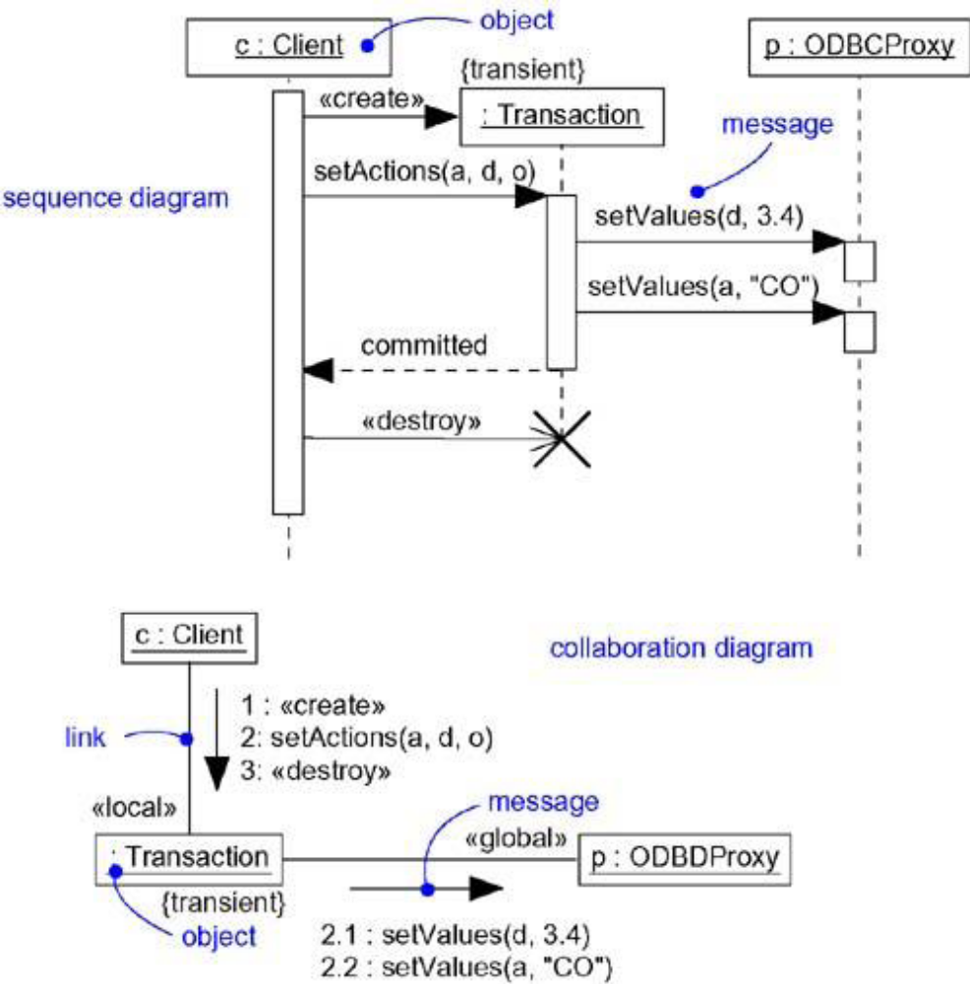

Figure. Interaction Diagrams
Terms and Concepts
- An interaction diagram shows an interaction, consisting of a set of objects and their relationships, including the messages that may be dispatched among them.
- A sequence diagram is an interaction diagram that emphasizes the time ordering of messages.
- Graphically, a sequence diagram is a table that shows objects arranged along the X axis and messages, ordered in increasing time, along the Y axis.
- A collaboration diagram is an interaction diagram that emphasizes the structural organization of the objects that send and receive messages.
- Graphically, a collaboration diagram is a collection of vertices and arcs.
Common Properties
- An interaction diagram is just a special kind of diagram and shares the same common properties as do all other diagrams• a name and graphical contents that are a projection into a model.
- What distinguishes an interaction diagram from all other kinds of diagrams is its particular content.

Contents
- Interaction diagrams commonly contain
- Objects or roles
- Links or communications
- Messages
- Like all other diagrams, interaction diagrams may contain notes and constraints.
Sequence Diagrams
- A sequence diagram emphasizes the time ordering of messages.
- As Figure shows, you form a sequence diagram by first placing the objects that participate in the interaction at the top of your diagram, across the X axis.
- Typically, you place the object that initiates the interaction at the left, and increasingly more subordinate objects to the right. Next, you place the messages that these objects send and receive along the Y axis, in order of increasing time from top to bottom.
- This gives the reader a clear visual cue to the flow of control over time.
- Figure. Sequence Diagram
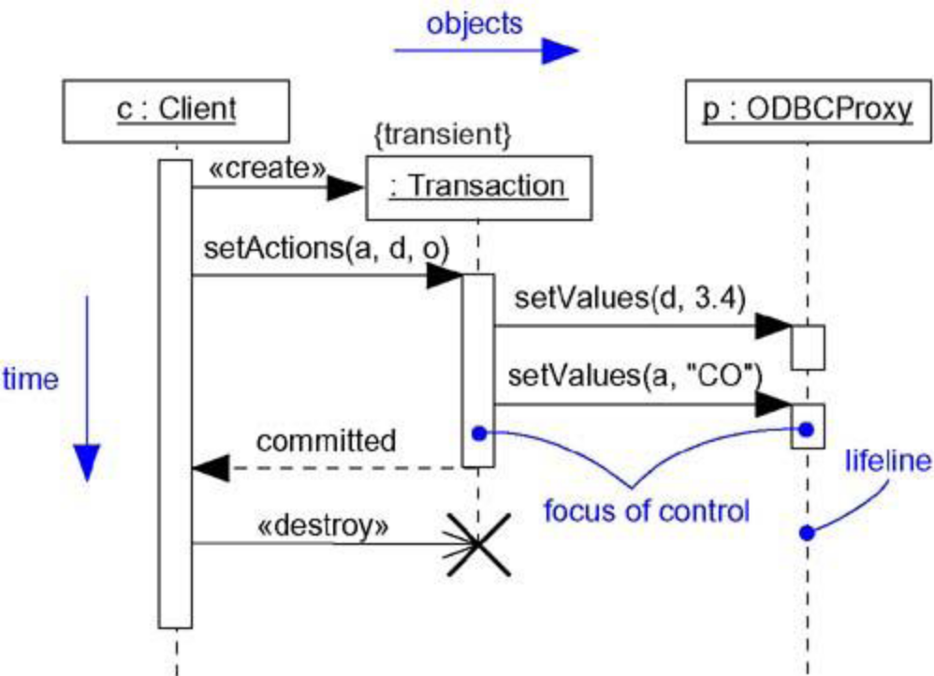
- Sequence diagrams have two features that distinguish them from collaboration diagrams.
1. Object lifeline: An object lifeline is the vertical dashed line that represents the existence of an object over a period of time. Most objects that appear in an interaction diagram will be in existence for the duration of the interaction, so these objects are all aligned at the top of the diagram, with their lifelines drawn from the top of the diagram to the bottom. Objects may be created during the interaction. Their lifelines start with the receipt of the message stereotyped as create. Objects may be destroyed during the interaction. Their lifelines end with the receipt of the message stereotyped as destroy (and are given the visual cue of a large X, marking the end of their lives).
2. Focus of control. The focus of control is a tall, thin rectangle that shows the period of time during which an object is performing an action, either directly or through a subordinate procedure. The top of the rectangle is aligned with the start of the action; the bottom is aligned with its completion (and can be marked by a return message). You can show the nesting of a focus of control. We can also shade the region of the rectangle during which the object's method is actually computing.
Collaboration Diagrams:
- A collaboration diagram emphasizes the organization of the objects that participate in an
interaction.
- As Figure shows, you form a collaboration diagram by first placing the objects that participate in the interaction as the vertices in a graph. Next, you render the links that connect these objects as the arcs of this graph. Finally, you adorn these links with the messages that objects send and receive. This gives the reader a clear visual cue to the flow of control in the context of the structural organization of objects that collaborate.
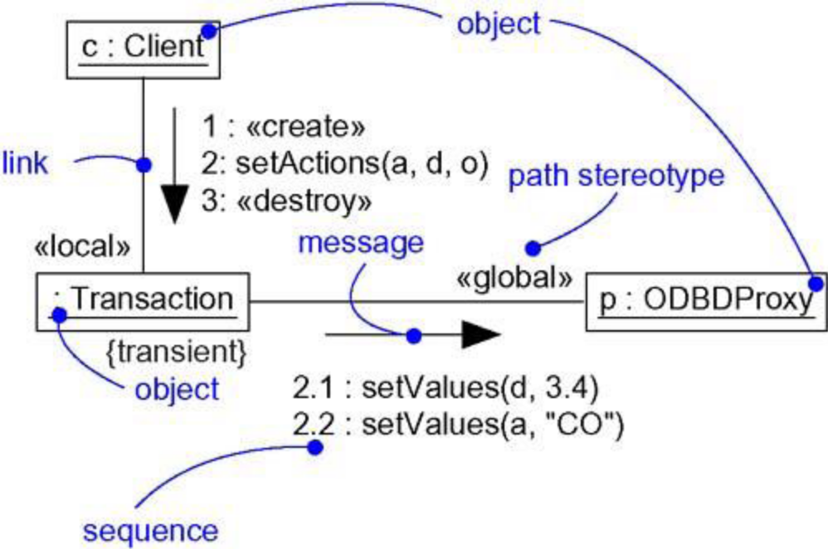
Figure Collaboration Diagram
- Collaboration diagrams have two features that distinguish them from sequence diagrams.
1. Path. To indicate how one object is linked to another, you can attach a path stereotype to the far end of a link (such as <<local>>, indicating that the designated object is local to the sender). Typically, you will only need to render the path of the link explicitly for local, parameter, global, and self (but not association) paths. You can use an advanced form of sequence numbers to distinguish concurrent flows of control, path stereotypes, complex branching and iteration can be more easily specified in activity diagrams.
2. Sequence number. To indicate the time order of a message, you prefix the message with a number (starting with the message numbered 1), increasing monotonically for each new message in the flow of control (2, 3, and so on). To show nesting, you use Dewey decimal numbering (1 is the first message; 1.1 is the first message nested in message 1; 1.2 is the second message nested in message 1; and so on). You can show nesting to an arbitrary depth.
- Most of the time, you'll model straight, sequential flows of control.
- Also we model more-complex flows, involving iteration and branching.
- An iteration represents a repeated sequence of messages. To model an iteration, you prefix the sequence number of a message with an iteration expression such as *[i := 1..n] (or just * if you want to indicate iteration but don't want to specify its details).
- An iteration indicates that the message (and any nested messages) will be repeated in accordance with the given expression.
- Similarly, a condition represents a message whose execution is contingent on the evaluation of a Boolean condition.
- To model a condition, you prefix the sequence number of a message with a condition clause, such as [x > 0]. The alternate paths of a branch will have the same sequence number, but each path must be uniquely distinguishable by a nonoverlapping condition.
- For both iteration and branching, the UML does not prescribe the format of the expression inside the brackets; you can use pseudocode or the syntax of a specific programming language.

Semantic Equivalence
- Sequence diagrams and collaboration diagrams are semantically equivalent and are isomorphic.
- As a result, you can take a diagram in one form and convert it to the other without any loss of information, as you can see in the previous two figures, which are semantically equivalent.
- It does not mean that both diagrams will explicitly visualize the same information.
- For example, in the previous two figures, the collaboration diagram shows how the objects are linked (note the <<local>> and <<global>> stereotypes), whereas the corresponding sequence diagram does not.
- Similarly, the sequence diagram shows message return (note the return value committed), but the corresponding collaboration diagram does not.
- In both cases, the two diagrams share the same underlying model, but each may render some things the other does not.
Common Uses
- You use interaction diagrams to model the dynamic aspects of a system. These dynamic aspects may involve the interaction of any kind of instance in any view of a system's architecture, including instances of classes (including active classes), interfaces, components, and nodes.
- When you use an interaction diagram to model some dynamic aspect of a system, you do so in the context of the system as a whole, a subsystem, an operation, or a class.
- You can also attach interaction diagrams to use cases (to model a scenario) and to collaborations (to model the dynamic aspects of a society of objects).
- When you model the dynamic aspects of a system, you typically use interaction diagrams in two ways.
1. To model flows of control by time ordering
- Here you'll use sequence diagrams. Modeling a flow of control by time ordering emphasizes the passing of messages as they unfold over time, which is a particularly useful way to visualize dynamic behavior in the context of a use case scenario. Sequence diagrams do a better job of visualizing simple iteration and branching than do collaboration diagrams.
2. To model flows of control by organization
- Here you'll use collaboration diagrams. Modeling a flow of control by organization emphasizes the structural relationships among the instances in the interaction, along which messages may be passed. Collaboration diagrams do a better job of visualizing complex iteration and branching and of visualizing multiple concurrent flows of control than do sequence diagrams.
Common Modeling Techniques:

Modeling Flows of Control by Time Ordering
- Consider the objects that live in the context of a system, subsystem, operation or class.
- Consider also the objects and roles that participate in a use case or collaboration. To model a flow of control that goes through these objects and roles, you use an interaction diagram; to emphasize the passing of messages as they unfold over time, you use a sequence diagram, a kind of interaction diagram.
To model a flow of control by time ordering,
- Set the context for the interaction, whether it is a system, subsystem, operation, or class, or one scenario of a use case or collaboration.
- Set the stage for the interaction by identifying which objects play a role in the interaction.
- Lay them out on the sequence diagram from left to right, placing the more important objects to the left and their neighboring objects to the right.
- Set the lifeline for each object. In most cases, objects will persist through the entire interaction. For those objects that are created and destroyed during the interaction, set their lifelines, as appropriate, and explicitly indicate their birth and death with appropriately stereotyped messages.
- Starting with the message that initiates this interaction, lay out each subsequent message from top to bottom between the lifelines, showing each message's properties (such as its parameters), as necessary to explain the semantics of the interaction.
- If you need to visualize the nesting of messages or the points in time when actual computation is taking place, adorn each object's lifeline with its focus of control.
- If you need to specify time or space constraints, adorn each message with a timing mark and attach suitable time or space constraints.
- If you need to specify this flow of control more formally, attach pre- and postconditions to each message.
- A single sequence diagram can show only one flow of control.
- Typically, you'll have a number of interaction diagrams, some of which are primary and others that show alternative paths or exceptional conditions.
- For example, Figure 18-4 shows a sequence diagram that specifies the flow of control involved in initiating a simple, two-party phone call. At this level of abstraction, there are four objects involved: two Callers (s and r), an unnamed telephone Switch, and c, the reification of the Conversation between the two parties. The sequence begins with one Caller (s) dispatching a signal (liftReceiver) to the Switch object. In turn, the Switch calls setDialTone on the Caller, and the Caller iterates on the message dialDigit. Note that this message has a timing mark (dialing) that is used in a timing constraint (its executionTime must be less than 30 seconds). This diagram does not indicate what happens if this time constraint is violated. For that you could include a branch or a completely separate sequence diagram. The Switch object then calls itself with the message routeCall. It then creates a Conversation object (c), to which it delegates the rest of the work. Although not shown in this interaction, c would have the additional responsibility of being a party in the switch's billing mechanism (which would be expressed in another interaction diagram). The Conversation object (c) rings the Caller (r), who asynchronously sends the message liftReceiver. The Conversation object then tells the Switch to connect the call, then tells both Caller objects to connect, after which they may exchange information, as indicated by the attached note.

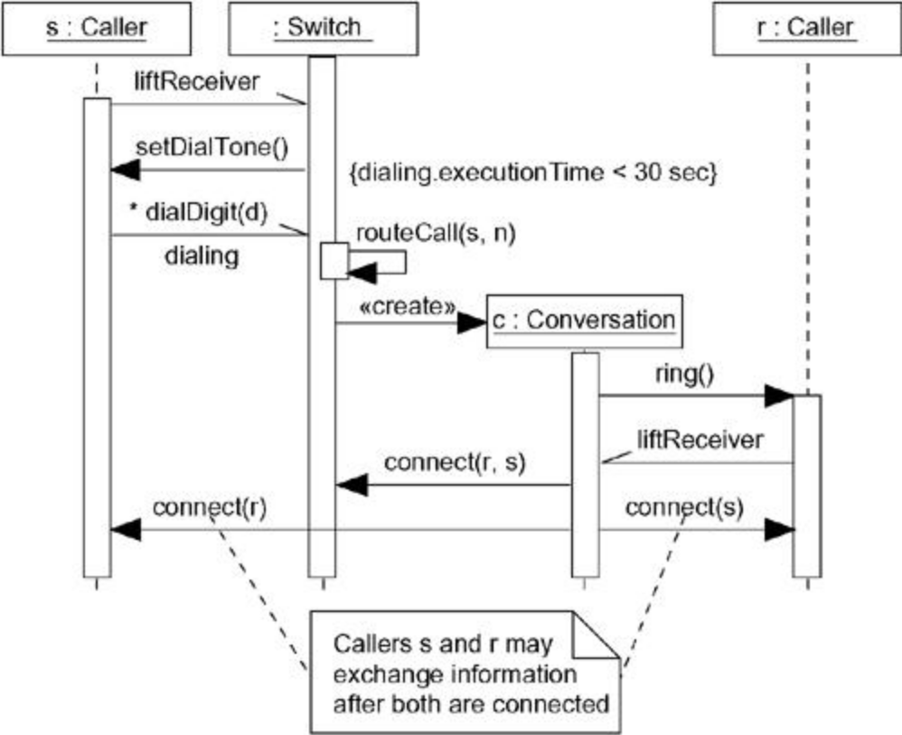

Figure. Modeling Flows of Control by Time Ordering

- An interaction diagram can begin or end at any point of a sequence.

Modeling Flows of Control by Organization
- Consider the objects that live in the context of a system, subsystem, operation, or class.
- Consider also the objects and roles that participate in a use case or collaboration.
To model a flow of control that goes through these objects and roles, you use an interaction diagram; to show the passing of messages in the context of that structure, you use a collaboration diagram, a kind of interaction diagram.
To model a flow of control by organization,
- Set the context for the interaction, whether it is a system, subsystem, operation, or class, or one scenario of a use case or collaboration.
- Set the stage for the interaction by identifying which objects play a role in the interaction.
- Lay them out on the collaboration diagram as vertices in a graph, placing the more important objects in the center of the diagram and their neighboring objects to the outside.
- Set the initial properties of each of these objects. If the attribute values, tagged values, state, or role of any object changes in significant ways over the duration of the interaction, place a duplicate object on the diagram, update it with these new values, and connect them by a message stereotyped as become or copy (with a suitable sequence number).
- Specify the links among these objects, along which messages may pass.
- Lay out the association links first; these are the most important ones, because they represent structural connections.
- Lay out other links next, and adorn them with suitable path stereotypes (such as global and local) to explicitly specify how these objects are related to one another.
- Starting with the message that initiates this interaction, attach each subsequent message to the appropriate link, setting its sequence number, as appropriate. Show nesting by using Dewey decimal numbering.
- If you need to specify time or space constraints, adorn each message with a timing mark and attach suitable time or space constraints.
- If you need to specify this flow of control more formally, attach pre- and postconditions to each message.
- As with sequence diagrams, a single collaboration diagram can show only one flow of control.
- For example, Figure. shows a collaboration diagram that specifies the flow of control involved in registering a new student at a school, with an emphasis on the structural relationships among these objects. You see five objects: a RegistrarAgent (r), a Student (s), two Course objects (c1 and c2), and an unnamed School object. The flow of control is numbered explicitly. Action begins with the RegistrarAgent creating a Student object, adding the student to the school (the message addStudent), then telling the Student object to register itself. The Student object then invokes getSchedule on itself, presumably obtaining the Course objects for which it must register. The Student object then adds itself to each Course object. The flow ends with s rendered again, showing that it has an updated value for its registered attribute.
- Figure. Modeling Flows of Control by Organization
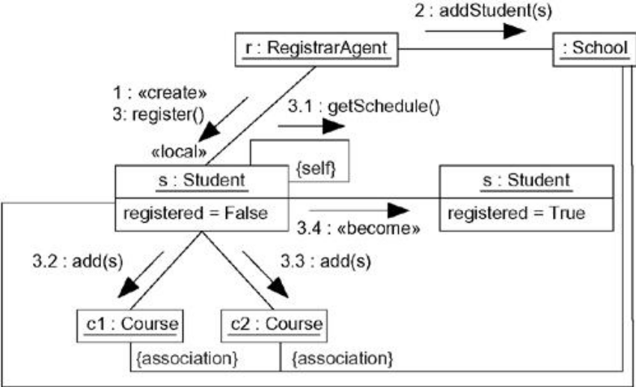
- Note that this diagram shows a link between the School object and the two Course objects, plus another link between the School object and the Student object, although no messages are shown along these paths. These links help explain how the Student object can see the two Course objects to which it adds itself. s, c1, and c2 are linked to the School via association, so s can find c1 and c2 during its call to getSchedule (which might return a collection of Course objects), indirectly through the School object.
Forward and Reverse Engineering
- Forward engineering (the creation of code from a model) is possible for both sequence and collaboration diagrams, especially if the context of the diagram is an operation. For example, using the previous collaboration diagram, a reasonably clever forward engineering tool could generate the following Java code for the operation register, attached to the Student class.
public void register() {
CourseCollection c = getSchedule();
for (int i = 0; i < c.size(); i++)
c.item(i).add(this);
this.registered = true;
}
- Reverse engineering (the creation of a model from code) is also possible for both sequence and collaboration diagrams, especially if the context of the code is the body of an operation.
- Segments of the previous diagram could have been produced by a tool from a prototypical execution of the register operation.

